PHY101: Introduction to Physics-1
Monsoon, 2020

Tutorial-9
1. Three particles of masses 3, 5 and 2 units are located at points (-1, 0, 1), (2, -1, 3) and (-2, 2, 1) respectively. Find the moment of inertia of the system of the particles about the y-axis.

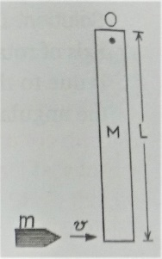
2. A thin rod of length L and mass M is hinged at a point O by a frictionless pivot, as shown. A small bullet of mass m moving with velocity v in horizontal direction hits the other end of the rod and gets embedded in it. Find the angular velocity of the rod about O just after the collision of the bullet with the rod.

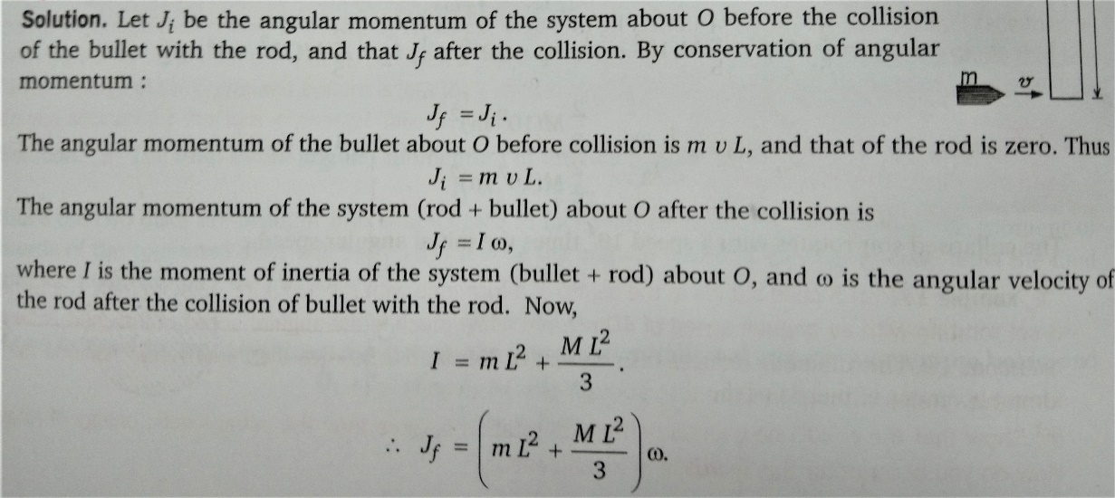
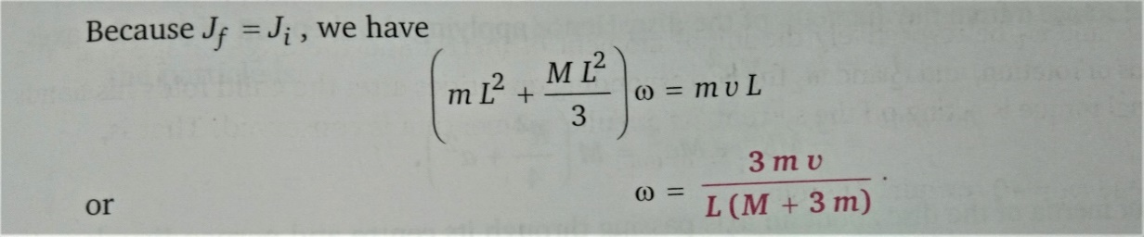

3. Consider an Atwood machine with blocks of mass m₁, m₂ (with m₁ > m₂), respectively. The pulley is of mass M and radius R; see the adjoining figure. Find out the acceleration of the blocks and tensions in the string. The rope is assumed to be massless and no slipping of the rope occurs over the pulley. Express your results in terms of m₁, m₂, M, R and g where g is the acceleration due to gravity.

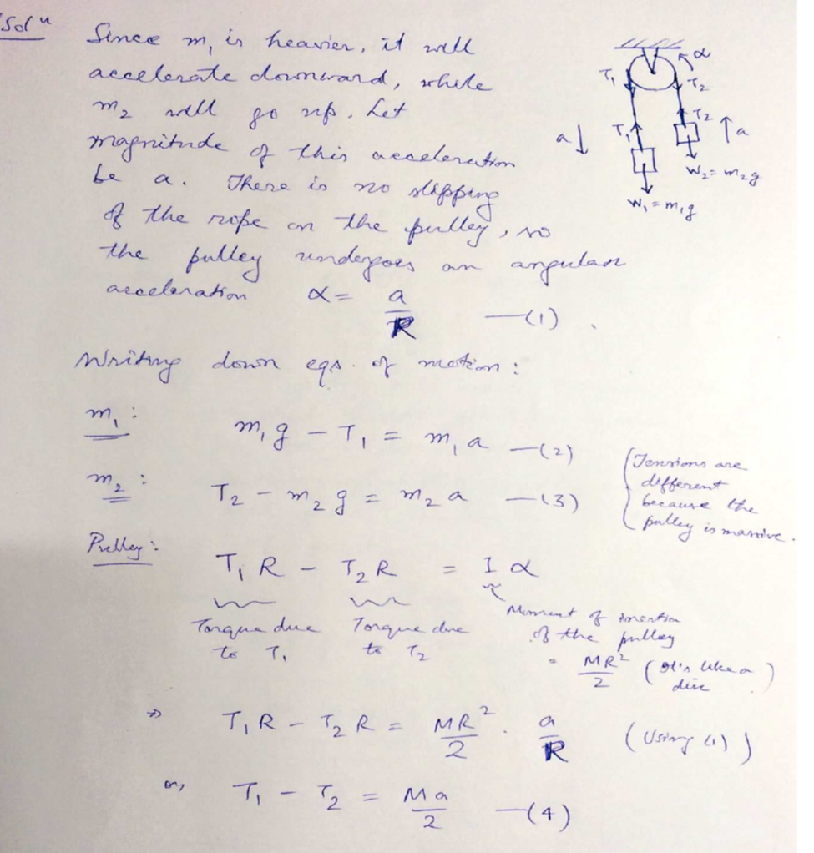

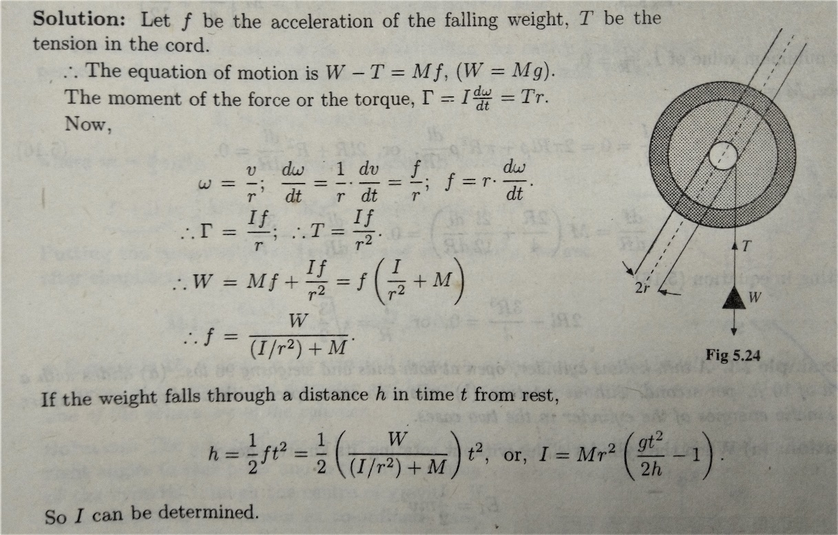
4. A flywheel rotating about horizontal axle of radius r has a cord wound round the axle and a weight is attached to the end of the cord. The weight falls giving rise to the rotation of the flywheel. Determine the moment of inertia of the flywheel.

5. A sphere of radius 2a and density ρ has an internal cavity of radius a, the diameter of which is the radius of the sphere. Find that the moment of inertia of the body about an axis perpendicular to the common diameter of the sphere and the cavity and at a distance x from the centre of the sphere.

